HTML Exercise
- Create a webpage that prints three lists with any information you want. One list should be an ordered list and the other lists should be an unordered list and glossary list.
- Create a page that will display an image that has a border of size 2, a width of 200, and a height of 200.
- Create a page which contains two links- one at the top and one at the bottom. On clicking the top link, the page has to scroll down to the bottom of the page where bottom link is present. On clicking the bottom link, the page has to scroll up to the top of the page.
- Design Html page that display the following content.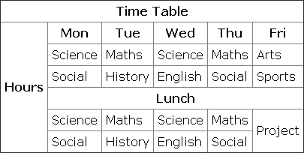
- Write a HTML program to create visitor information capture. The page should have the heading “Visitors information” and should ask the following information from the user :
• Email address using a textbox ,
• User’s interest web for research or purchase as check box
• occupation as drop down format and preselected value should be given as (select one),
• Check “want us to send you junk emails?” and the options given are “absolutely” and “no way man” using the radio button.
• A horizontal line divides the heading and the body content. Once all the inputs are given by the user should be able to submit or reset.
• This whole form should tabulated using table
- Design a HTML page as shown in figure using form tags.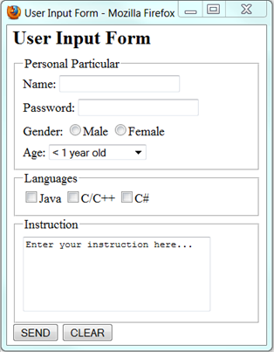
- . Write a HTML code to display the HTML page as described below:
• Create a page which is divided in 3 parts. 30% horizontally on top and the rest 70 % bellow is split vertically in 2 parts again 30 % and 70% each
• The Top header frame should display an image
• Left side below frame should have a menu of “Font” and “Alignment”.
• If we click on “Font” link a different page which contains 5 different fonts with font’s names should be shown on the RHS
• If we click on “Alignment” link a different page which contains a different alignment type should be shown on the RHS frame.
• For this create 2 webpages named Font and Alignment
• Font page should have 5 names of different fonts displayed like this
Agency FB
Cambria
Elephant
• Alignment page should have sample text aligned to different alignments
- Design a website for a startup company that contains the following features.
Website should have at least three page.
  - Home page should have the links to other two pages and should have frame.
  - Any one page should have tables to represent the data.
  - Any one page should have background image.
  - Display an image that when clicked will link to a search engine of your choice (should be opened in a new window)
  - Pages with a link at the top of it that when clicked will jump all the way to the bottom of the page. At the bottom of the page there should be a link to jump back to the top of the page.

